**3. Spectroscopy is a vital tool for astronomers and provides a wealth of information**

***Account for the production of emission and absorption spectra and compare these with a continuous blackbody spectrum***

* Continuous Blackbody Spectra
  + We saw in Ideas to Implementation that all hot bodies radiate a range of electromagnetic radiation, with the intensity and frequency of the peak emission increasing with temperature.
  + In regard to astrophysics, if a light source is a hot and glowing solid, liquid or high-pressure gas, then a continuous rainbow-like spectrum will be produced, since the light source constitutes a black body. This type of spectra is known as continuous blackbody spectra. For example, the tungsten filament in incandescent light globes will produce a continuous blackbody spectrum.
* Now, before we go on to talk about emission and absorption spectra, we need to have some context:
  + In an atom, we know that electrons orbit the nucleus in defined energy levels, as shown in the diagram. Therefore, a precise quantity of energy is required for an electron to move from one energy level to another. In fact, with $E=hf$ and each “jump” involving a precise quantum of energy, any energy absorbed (to move up energy levels) or emitted (after moving down energy levels) must have a precise frequency.

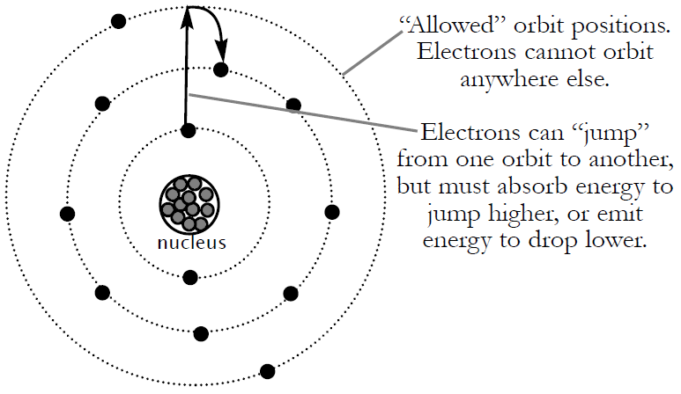

* Emission Spectra
  + An emission spectrum has the appearance of a long, black rectangle upon which discrete bright coloured bands appear. Emission spectra are produced by hot, glowing gases of low density. Thus, sources of emission spectra include fluorescent light tubes and sodium vapour street lights.
  + *How Emission Spectra Work* 🡪 Emission spectra are produced when low pressure gas is heated or energised (e.g. by applying an electric potential). This results in electrons, of the gas atoms, absorbing energy and jumping to a higher energy level. Soon after, the electron falls back to its “ground state” (i.e. original energy level), emitting the energy it had absorbed, now in the form of EMR. However, only particular frequencies that correspond exactly to the energy difference between the two energy levels will be emitted. These frequencies are represented by the bright lines that can be seen when examining emission spectra.
* Absorption Spectra
  + An absorption spectrum has the appearance of a continuous spectrum upon which discrete black lines appear. These lines represent wavelengths that are missing from the otherwise continuous spectrum. Absorption spectra are produced by a cool, non-luminous gas placed in front of a continuous spectrum source, such as an incandescent light bulb.
  + *How Absorption Spectra Work* 🡪 As the continuous spectrum shines through the gas, the atoms of the gas will absorb particular wavelengths/frequencies. These frequencies correspond to differences between energy levels within the atom, since absorbing these frequencies raises electrons to a higher energy level. EMR is then re-emitted as the electrons drop back down to their original energy levels. However, this radiation is re-emitted in all directions. Therefore, the wavelengths that have been absorbed and re-emitted in various directions appear as dark lines against the bright continuous spectrum.
    - Simply put, by comparing it to the formation of an emission spectrum, just as an element is capable of emitting certain frequencies of light, so too it is capable of absorbing these same frequencies – thus producing an absorption spectrum.

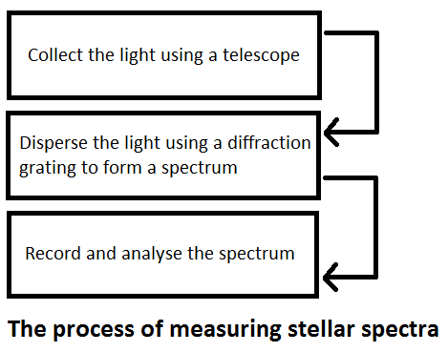***Describe the technology needed to measure astronomical spectra***

* But, what is the instrument for spectroscopy? It is a *spectroscope* – a device used to spread light into its spectrum. A spectroscope can be attached, for example, to the eyepiece of a telescope to examine the spectra of starlight.
* It is made up of several elements working together. There must first be a light source and this will be followed by several slits to collimate the light into a flat, vertical beam. The light then enters the dispersive element. This is either a triangular prism or a diffraction grating, both of which have the ability to disperse light out into its spectrum. Because the light is in the form of a flat beam, the spectrum spreads out as a rectangular strip. The spectrum can be recorded on a photographic plate.
* However, nowadays, spectra are increasingly being recorded and analysed using charged coupled devices (CCDs), which convert 80% of the incoming photons into the image. This is in contrast to photographic plates, which are only able to capture 1% of incident photons. Using CCDs means that less exposure time is needed to obtain spectra.
* Nowadays, diffraction gratings are used in favour of glass prisms. This is because glass prisms absorb some light and reduce the sensitivity of the system. In contrast, diffraction gratings use interference effects to spread out the frequencies, and thus are superior in both resolution and sensitivity.

***Identify the general types of spectra produced by stars, emission nebulae, galaxies and quasars***

* Stars **(absorption spectra)** – Stars produce absorption spectra. The reason for this is that the core of the star is hot, dense gas and therefore emits a continuous black body spectrum. Surrounding the star, however, is a cooler and less dense atmosphere, which absorbs certain wavelengths and re-emits them away, resulting in an absorption spectrum. (Thus, the wavelengths of the absorption lines can then be used to determine what elements and molecules are present in the star’s atmosphere.)
* Emission Nebulae **(emission spectra)** – Emission nebulae are hot interstellar gas clouds that surround very hot stars. Emission nebulae absorb UV radiation emitted by the surrounding stars. Thus, emission nebulae re-emit the energy in the form of an emission spectrum. The spectral lines found for emission nebulae represent the gases found in the cloud (e.g. hydrogen, nitrogen and oxygen).
* Galaxies **(continuous blackbody spectra)** – The light from a galaxy is a combination of light from the billions of stars (absorption spectra) and emission nebulae (emission spectra). Therefore, light from a galaxy is essentially a continuous blackbody spectrum, not only of visible light but also of wavelengths spanning the entire electromagnetic spectrum.
  + In fact, most spectra obtained from galaxies are strongly red-shifted as they are receding from us.
* Quasars **(emission spectra)** – Quasars are extremely distant and old objects that emit enormous amounts of energy. Quasars are thought to be massive black holes, and they emit energy as matter is ‘swallowed’ into the intense gravitational field of the black hole. This results in the formation of emission spectra.
  + In fact, the red-shift evident in the emission spectra of many quasars shows astronomers that quasars are receding from us at speeds as fast as $0.9c$.

***Describe the key features of stellar spectra and describe how these are used to classify stars***

* A stellar spectrum consists of an approximate black body radiation spectrum (corresponding to the star’s surface temperature), superimposed with absorption lines characteristic of the elements and molecules that are present in the star’s atmosphere.
* Most stars are made up of a set of very similar elements and compounds, yet their spectra can vary greatly. The reason is that different star temperatures produce different degrees of excitation/ionisation of the various atoms and molecules. This in turn produces different absorption lines of varying strength.
* At lower temperatures, molecules can exist near the surface of a star and they produce particular spectral lines. At hotter temperatures, these molecules can no longer exist and the spectral lines produced belong to neutral atoms. At even higher temperatures, the atoms become ionised, and the spectral lines produced are characteristic of these ionised particles.
* Consequently, stars have been classified into a set of spectral classes, each designated by a letter, according to the main spectral lines evident, which itself is influenced by the star’s temperature. When placed in order of decreasing temperature they are the seven spectral classes O, B, A, F, G, K and M. Also, for each spectral class, there are a further 10 subdivisions using 0 to 9 (e.g. B9, A0, A1, …, A8, A9, F0, etc.)

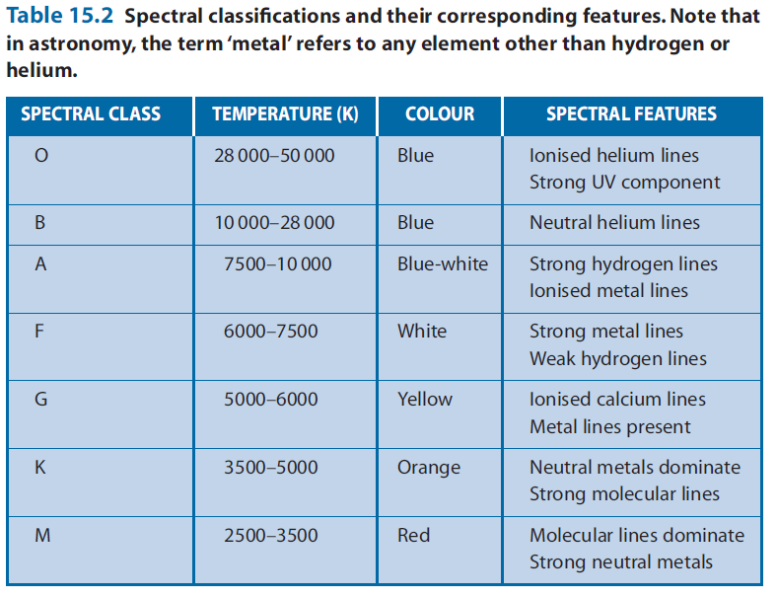

* *Example Q* 🡺
  + **Question** 🡪 Why are very few molecular lines observed in the spectra of stars?
  + **Solution** 🡪 Molecules do not exist in the outer atmospheres of most stars, since the temperature is too high for the atoms in the molecules to stay bonded together. However, some molecular lines are observed for class K and M stars, since their surface temperature is relatively low.
* Here is a very good summary of what spectral features we observe for stars of differing temperatures:

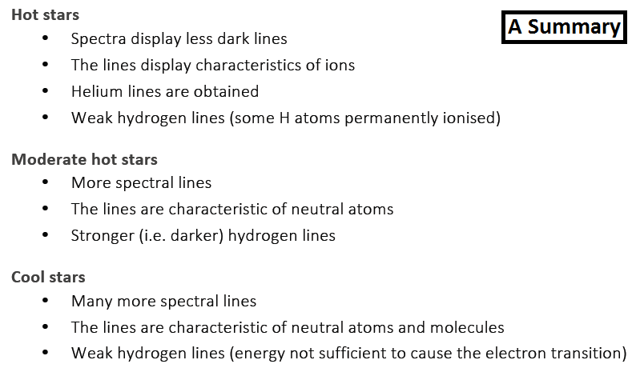

***Describe how spectra can provide information on surface temperature, rotational and translational velocity, density and chemical composition of stars***

Surface Temperature

* 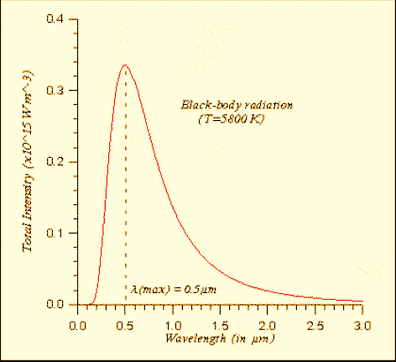As mentioned above, the absorption spectrum produced by a star depends on the surface temperature of the star. Thus, once a star’s spectral class has been identified by examining its spectral lines, then the star’s surface temperature can be deduced.
* However, it also important to note that there is another method. By using a spectrophotometer, the intensity of each emitted wavelength can be examined and an intensity vs wavelength graph can then be plotted, like the one to the right.
* From the graph, the wavelength of maximum energy output (known as peak intensity wavelength) can be identified. Once this is determined, the star’s surface temperature can be calculated using Wien’s Law: $T=\frac{2.9×{10}^{-3}}{λ_{max}}$
  + T is the temperature of the star, in Kelvin (K)
  + λmax is the peak wavelength, in metres (m)

Wait a minute!

* Before we talk about rotational and translational velocity, we need to revisit the concept of the Doppler Effect. The Doppler Effect refers to the apparent shift in the wavelength (and frequency) of a wave when there is relative motion between the source of the wave and the observer.
* Now, let’s look at this, in terms of astrophysics:
  + If we obtain a spectrum from a star at rest (relative to us), then there is no Doppler shift in the spectrum obtained (i.e. no relative motion means no apparent shift in spectral lines).
  + If a star was moving away from us (or indeed us from it – only relative motion matters), then the spectral lines would appear to shift towards the longer wavelengths (i.e. the redder part of the spectrum). Thus, we call this ‘red-shift’. On the other hand, if a star was moving towards us, then the spectral lines would appear to shift towards the shorter wavelengths (i.e. the bluer part of the spectrum). Thus, we call this ‘blue-shift’.
  + The amount of the shift, of course, depends on the relative velocity between the source and the observer. The greater the relative velocity, the greater the shift of the spectral lines.

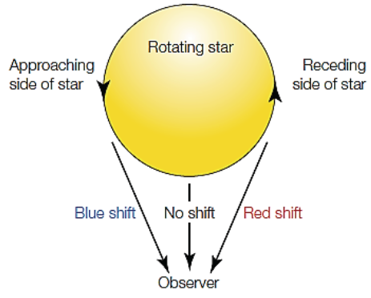Rotational Velocity

* When a star is rotating, one side is travelling away from us while the other side is coming towards us.
* Light emitted from the receding side will be red‐shifted, in accordance with the star’s rotational velocity. Similarly, light from the approaching side will be blue‐shifted to a similar extent.
* This results in a simultaneous red and blue shift, meaning that the star’s spectral lines experience a blurred widening. The faster the star’s rotational velocity, the greater this broadening effect is.
* By analysing the amount of widening, along with an estimation of the size of the star, we can then calculate the rotational velocity of the star.

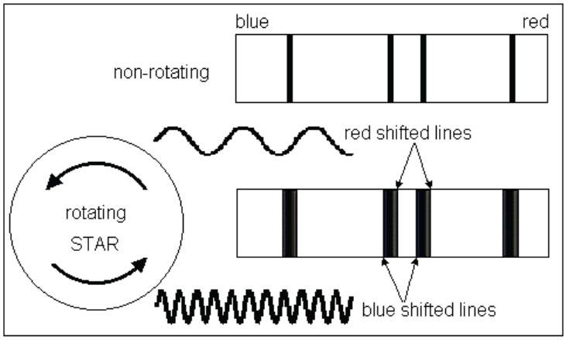

Translational Velocity

* Translational velocity is defined as the velocity of a celestial object, relative to an Earth observer. To calculate translational velocity, many factors have to be considered. Let’s try to understand this by using a diagram (on the next page).
* So, firstly, astronomers are required to determine the star’s radial velocity (vr) – i.e. the velocity of the star parallel to our line of sight. This is calculated by analysing the extent of the Doppler shift evident in the star’s spectral lines. Of course, blue-shift will occur if the star’s radial velocity is towards us, whereas red-shift if the star’s radial velocity is away from us. And, indeed, the greater the shift, the faster the star’s radial velocity.
* 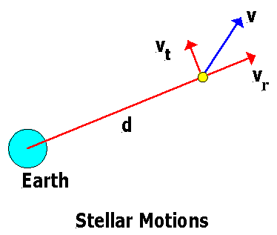Then, astronomers calculate the star’s tangential velocity (vt) – i.e. the velocity of the star perpendicular to our line of sight. This is calculated by doing mathematical calculations, which involve using measurements of the star’s distance away and the number of arcsecs the star appears to move each year.
* Hence, once we know the star’s radial and tangential velocities, we can do a simple vector addition to obtain the star’s translational velocity.

Density

* The density of a star can be inferred from the width of the star’s spectral lines.
* A less dense star will have fewer collisions between atoms, and thus have very sharp and narrow spectral lines. On the other hand, a more dense star will have more collisions between atoms, resulting in blurred and broaden spectral lines.
* Therefore, the denser the star, the more widened the spectral lines will be.

Chemical Composition

* 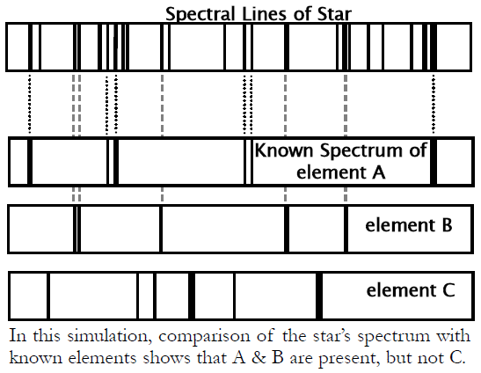As previously mentioned, the molecules, atoms and ions in a star’s atmosphere produce the absorption lines on a star’s spectrum. Of course, each molecule, atom and ion has a unique absorption spectrum. As a result, comparing the absorption lines of a star to those produced by an element under laboratory conditions indicates the presence of the particular element in the star’s atmosphere. The intensity of the absorption lines gives an indication of the abundance of that element. Through this, an astronomer is given insights into the star’s chemical composition.
* In this manner, helium was first discovered in the Sun before it was isolated on Earth. And also through the process described above, we now know that stars are mostly made up of hydrogen and helium, with small amounts of some other elements. This is only known due to spectroscopy.

***Perform a first-hand investigation to examine a variety of spectra produced by discharge tubes, reflected sunlight, or incandescent filaments***

* First of all, some safety precautions:
  + keep a safe working distance from any high voltage or spark discharge apparatus that is utilised, in order to limit exposure to high frequency radiation;
  + never ever point your spectroscope at the sun;
  + place any discharge tubes that are used in a sturdy position with cushioning, as they are depressurised and have the potential to implode.
* Here’s the method to follow:

1. In a darkened room, set up discharge tubes with a variety of different gases (sodium, hydrogen, neon and mercury are highly suitable, for example).
2. By looking through a hand-held spectroscope, observe the spectra produced by each discharge tube and sketch your observations. Such spectra should be emission spectra, with each gas producing an emission spectrum with varying spectral lines.
3. Next, observe the spectrum produced by an incandescent light globe. Try repeating this for different voltage settings, noting the effect of this change in temperature on both the intensity and range of spectral lines. The spectra observed during this section should be continuous blackbody spectra.
4. Finally, go outside and observe spectra from reflected sunlight. This should again be a continuous blackbody spectrum.

***Analyse information to predict the surface temperature of a star from its intensity/wavelength graph***

* Discussed in a Previous Dot Point